* In the Virtual machines page, select Add.
* In the Basics tab, under Project details, make sure the correct subscription is selected and then choose to Create new resource group. Type myResourceGroup for the name.

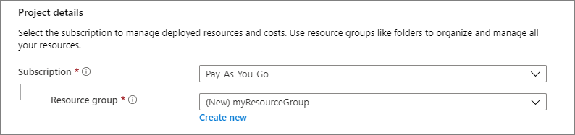

* Under Instance details, type VM Name for the Virtual machine name and choose Region, and then choose server for the Image and size.

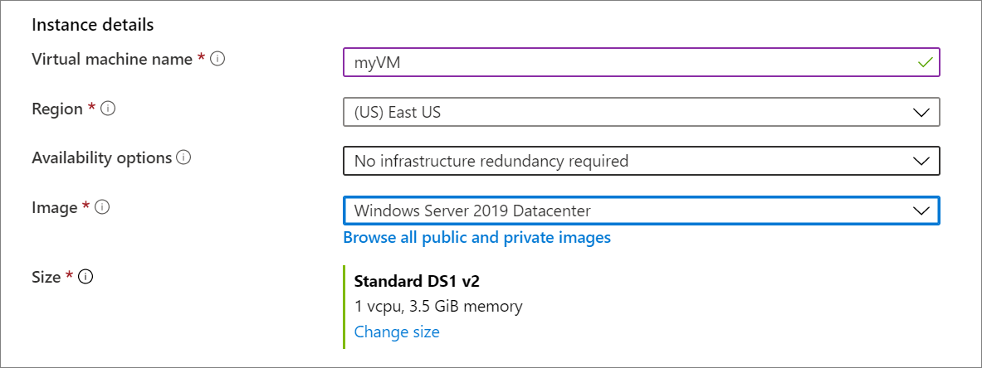

* Under Administrator account, provide a username and a password. The password must be at least 12 characters long and meet the defined complexity requirements.

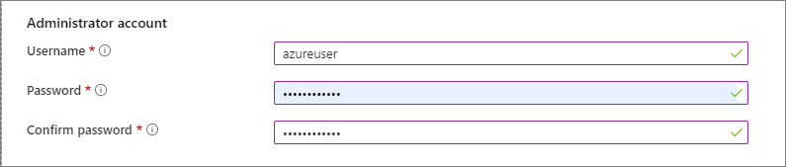

* Under Inbound port rules, choose Allow selected ports based on the customer request.

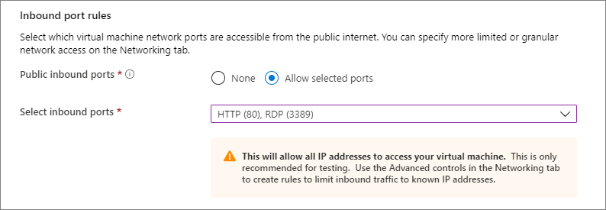

* Select the License type for the vm based on the customer request



Then Review and Create